Final Year Project Work Guidelines B.Tech.
(Computer Science and Engineering (Artificial Intelligence))
2020R1 Course

(With effect from Academic Year 2025-26)

Project Title | : | Secure Real-Time Email Monitoring with  Envelope Encryption and LLM-Driven Smart Reply Classification
Project Area | : | Generative AI, Natural Language Processing and Cybersecurity
Internal Guide | : | Dr. Nilesh Sable
Sponsoring industry | : | Company Sponsored - SenAI Solutions Pvt Ltd

SYLLABUS

Project Work (CAUA40204)

Examination Scheme:
Continuous evaluation: 100 Marks
PR/OR:50 Marks

Course Objectives:
- To apply SDLC and meet the objectives of proposed development or research work
- To test rigorously before deployment of work in objective 1
- To validate the work undertaken during objective 1 and 2
- To consolidate the development or research work as project report.
Course Outcomes:
On completion of the course, student will be able to–
- Produce evidence of independent investigation
- Analyze the results and their interpretation intensively and critically.
- Report and present the original results in an orderly way and placing the open questions in the right perspective.
- Link techniques and results from literature as well as actual research and future research lines with the research.
- Appreciate practical implications and constraints of the specialist subject
Guidelines
The student shall complete the work of the Project which will consist of problem statement, literature review, SRS, Model and Design, Selection of Technology and Tools, Installations, UML implementations, testing, Results, performance discussions using data tables per parameter considered for the improvement with existing/known algorithms/systems and comparative analysis and validation of results and conclusions. The candidate shall deliver a presentation on the advancement in Technology pertaining to the selected project topic. The examinee will be assessed by a panel of examiners of which one is necessarily an external examiner. The assessment will be broadly based on work undergone, content delivery, presentation skills, documentation, question- answers and report. The student shall prepare and submit the report of Project work in standard
format for satisfactory completion of the work that is the duly certified by the concerned guide and head of the Department/Institute.

Index
Sr. No. | Content | Page No.
1 | Certificate | 5
2 | Acknowledgement | 6
3 | Undertaking by Students | 7
4 | Project Work Schedule | 8
5 | Group Details | 9
6 | Abstract | 10
7 | List of Figures | 11
8 | List of Tables | 12
9 | Chapter 1: Introduction | 13
9.1 | Introduction | 13
9.2 | Problem Statement | 14
9.3 | Scope of Research | 15
9.4 | Research Hypothesis | 16
9.5 | Objectives | 17
9.6 | Organization of the Report | 17
10 | Chapter 2: Literature Review | 19
10.1 | Background | 19
10.2 | Review of Existing Work | 20
10.3 | Literature Survey Table | 21
10.4 | Summary of Literature Review & Research Gap | 23
11 | Chapter 3: Methodology | 26
11.1 | Materials | 26

11.2 | Methodological Approach | 27
11.3 | Algorithmic Framework | 27
11.4 | System Architecture | 28
11.5 | Use Case Model | 29
11.6 | Systemic Workflow | 29
11.7 | Evaluation Method | 32
11.8 | Experimental Process | 32
11.9 | Ethical & Practical Considerations | 33
11.10 | Summary of Methodology | 33
12 | Chapter 4: Results and Discussion | 35
12.1 | Summary of Results and Discussion | 35
13 | Chapter 5: Conclusion and Recommendations | 41
13.1 | Conclusion | 41
13.2 | Recommendations and Future Work | 42
14 | References | 44

CERTIFICATE

This is to certify that the project entitled Secure Real-Time Email Monitoring with Envelope Encryption and LLM-Driven Smart Reply Classification has been successfully completed by:
Roll No. | GR. No. | Division | Name of Student
04 | 22210260 | A | Manoj Umapathi Naidu
46 | 22211583 | A | Nishchay Jaykumar Bhardwaj
47 | 22211156 | A | Sahil Nitin Kadam

In partial fulfillment of the requirements for the award of the degree of Bachelor of Technology (B.Tech.) in Computer Science and Engineering (Artificial Intelligence) From Vishwakarma Institute of Information Technology, Pune for the academic year 2025–2026.
This work has been carried out under the guidance of Dr. Nilesh Sable, Department of Computer Science and Engineering (Artificial Intelligence).
It is certified that this project is the students’ original work and has not been submitted, either in part or full, for the award of any other degree or diploma.
Date: 13/04/2026

Dr. Nilesh Sable Dr. Anuradha Yenkikar.
Project Guide Project Coordinator

H.O.D.
Department of Computer Science and Engineering
(Artificial Intelligence).

ACKNOWLEDGEMENT

We express our sincere gratitude to the Department of Computer Science and Engineering (Artificial Intelligence), Vishwakarma Institute of Information Technology, Pune, for providing us with the opportunity to carry out this project.

We heartfully thank our internal guide, Dr. Nilesh Sable, for their valuable guidance, constant support, and insightful feedback throughout the project. We also thank our Project Coordinator and all faculty members for their encouragement and academic assistance.

We are grateful to our classmates, laboratory staff, and everyone who helped us directly or indirectly during the development of this work. Lastly, we thank our families for their continuous motivation and support.

1. MANOJ NAIDU.
2. NISHCHAY BHARDWAJ.
3. SAHIL KADAM.

UNDERTAKING BY STUDENTS

We, the students of BTech Computer Science (AI). hereby assure that we will follow all the rules and regulations of VIIT related to the project work for the academic year 2025-26. The Project entitled Secure Real-Time Email Monitoring with Envelope Encryption and LLM-Driven Smart Reply Classification will be fully designed and developed by us and no part of the project/ full project will be designed and developed by any external entity or copied from some external resources. We are fully aware that copying or taking help of any external agency in the development of our project is totally unethical and illegal. The examiners have / University has full rights to initiate an action against us as per university norms if involved in unfair/ illegal/ unethical work.

Sr.  No. | Roll No. | Name of Student | Signature
1 | 4 | Manoj Umapathi Naidu
2 | 46 | Nishchay Jaykumar Bhardwaj
3 | 47 | Sahil Nitin Kadam

PROJECT WORK SCHEDULE

Sr.  No. |  | Date
1. | Registration of Project Groups | Week 1
2. | Allocation of Guide and Project Topic Submission | Week 2
3. | Submission of Abstract to Project Guide and Project Coordinator in the Prescribed Format | Week 3
4. | Project Review – 0 (For topic and scope finalization) | Week 4
5. | Project Review - I | Week 7
6. | Project Review - II | Week 10
7. | Verification of Project Work Book By Internal Guide (before submission of Preliminary Project Report) | Week 11
8. | Submission of Final Preliminary Project Report in Prescribed Format | Week 12
 | External Term-work Evaluation | As per Institute  Schedule

BTECH PROJECT GROUP DETAILS
(Academic Year:2025-26 Sem:08)

Project Group No.: 04
Project Title: Secure Real-Time Email Monitoring with
Envelope Encryption and LLM-Driven Smart Reply Classification

Sr.  No. | Roll No. | Name of the Student | Mobile No. | Email id | T. E.  Result
1 | 4 | Manoj Naidu | 8149623527 | manoj.22210260@viit.ac.in
2 | 46 | Nishchay Bhardwaj | 9325046223 | nishchay.22211583@viit.ac.in
3 | 47 | Sahil Kadam | 7410054808 | sahil.22211156@viit.ac.in

Name & Signature Internal Guide

Name & Signature of External Guide

Signature of Head of
Department

Abstract
The flood of messages received is rendering it hard to respond to their emails in teams in a timely manner. These instances render the email management a guessing game since in most instances, an email can only be examined by a human being to establish whether or not an email should be forwarded. This automation is not an easy task, and it is essential to not spill confidential data and control the content of the messages inappropriately. It is a speedy and secure system implemented in this project. It scans emails in real time, constantly checking accounts via an event-driven architecture, and stores data privately and has a series of "smart tools" which can use a large language model to assist in categorization and response. Using OAuth to access Gmail, one can add updates to the system using webhooks. The system also has a flexible architecture that eradicates duplicates, structures information, discerns context and even composes email responses. Data is securely stored in encrypted envelopes which are regularly updated. With hashed indexes, you have the ability to search without even knowing what is in the emails. Model-based intelligence tests all the information based on the nature, feeling, and urgency of the information and decides what to do with it: to act automatically, relay the information to a human being or to drop it. During evaluation, the system recorded an F1 score of 0.72 for semantic triage and successfully processed concurrent real-time payloads with a peak throughput of 2.66 emails per second, while adding only a 0.02% latency overhead for AES-256-GCM encryption In the end, the project will present a privacy-oriented, active email monitoring system that will combine trigger-driven information gathering, privacy-enhancing strategies of storing data, and AI-based filtering and response creation into a single, deployable system.

LIST OF FIGURES

Figure No. | Title
Figure 1.1 | Proposed 5-Layer System Architecture
Figure 3.1 | Use Case Diagram of the Secure Email Monitoring
Figure 3.2 | Phase 1 - Authorization and Initialization Workflow
Figure 3.3 | Phase 2 - Ingestion, Security, and Processing Workflow
Figure 3.4 | Phase 3 - Delivery and Orchestration Workflow
Figure 4.1 | End-to-End Processing Latency Profile (P50 and P95 Across Repeated Runs)
Figure 4.2 | Throughput Behavior Under Increasing Concurrent Notification Load

LIST OF TABLES

Table No. | Title
Table 2.1 | Literature Survey of Existing Systems and Methodologies
Table 4.1 | Dataset Composition and Label Distribution for the 450-Email Evaluation Corpus
Table 4.2 | LLM Triage Performance Across Category, Sentiment, Priority, and Reply-Mode Tasks
Table 4.3 | System Runtime and Security Overhead Metrics in Deployment-Oriented Testing

CHAPTER 1: INTRODUCTION

1.1 Introduction
Email remains a significant means of communication through which businesses communicate, coordinate activities and relationships with customers within the digital realm. The quantity of digital messages has increased tremendously within the past decade. Whereas it could be true that various productivity tools could be used to sort out the incoming mails in terms of filtering and sorting by some key words or some particular senders, there is a factual need of having a more advanced automation, as one of the solutions to solve those unnecessary time-consuming processes. Such activities usually entail the development of contextual responses to particularities of the incoming messages and informing the administrators about high-priority or urgent ones.
One example of this is in regular business operations whereby, automatically, customer questions are answered on availability of products, on the status of orders made, real time prices, or real time generation of quotes and invoices of purchased items. At present, the way of handling emails in such situations is rather a case of luck and still involves a human factor. It involves individuals to interpret the situation, the emotional tone of the sender and make a judgment whether to send an email to a certain department or not. This automation can be quite a jiggery, especially due to the fact that it is essential to avoid spilling confidential information, revealing unreasonable context or providing too much internal information.
In order to overcome this issue, this project suggests a new backend architecture which is designed with the intention of real-time emailing and smart monitoring. The basic idea behind this architecture is safety. The system springs into action with instant push notifications for incoming emails, enabling it to operate without any delays. Instead of using old-fashioned, polling-based techniques, which can consume API quotas and introduce latency, real-time information is collected and causes state-of-the-art, event-based parsing. Only the information which is relevant is processed and the rest which is not necessary or repetitive is omitted. The semantic meaning of the data that comes in is derived with help of Large Language Models (LLM) which are founded on clarity and context.
One of the key aims of this implementation is to significantly reduce the number of manual administrative labor but still have people in the decision making process. It is, after all, the last word and one day the users have the final say. A hybrid system, rather than a complete automated one, which can lead to errors or policy breach, where machines perform most of the tasks, and humans handle the complicated cases, is adopted.
A certain aim of such implementation is to make the amount of practical administrative work much smaller and yet remain people engaged in the decision-making process. Finally, all the decision lies with the users when it really counts. Rather than a completely automated system that might result in mistakes or breach of policies, a middle ground solution is used- machines will do most of the work, but the tricky cases will be monitored by human beings.

1.2 Problem Statement
The guiding question that this work is answering is: How can organizations downsize the triage, routing and drafting of responses to the flood of emails they receive in real-time and yet maintain data privacy, avoid sensitive information being exposed and the complicated context of tangled email threads?
This problem can be further subdivided into the following sub-problems:
- Latency Problem: Existing solutions for e-mail polls generally suffer from poor efficiency and speed. It is hard to react quickly to all the numerous incoming emails by the teams.
- Contextual AI Problem: Simple rule-based classifiers and machine learning classifiers may fail to comprehend the purpose of a particular email, and respond to it accordingly.
- The Privacy Problem: Quite a lot of AI models that appear on the market are highly responsive but are not concerned about keeping data private and managing keys appropriately. Private company emails using external large language models can cause data leakage in the case that they are not run within secure and encrypted systems.

1.3 Scope of Research
The focus of this B.Tech final year project is all about creating, developing, and thoroughly testing a robust 5-layer backend architecture (refer Figure 1.1). Here’s a quick breakdown of each layer:
- Authorization Layer: Authorization layer will provide secure access to mailboxes using Google. OAuth 2.0 and handling JWT token exchanges.
- Ingestion Layer: It receives real-time push notifications using Google Cloud Pub/Sub. webhooks, which is why it is simple to retrieve user emails.
- Semantic Processing Layer: This layer will be linked with Gemini API to analyze. various aspects of emails, such as category, sentiment, and priority, while also figuring out the most appropriate response- which could be automatic, manual or not.
- Secure Persistence Layer: It takes care of database storage with AES-256-GCM envelope encryption, which guarantees that the data encryption keys are encrypted by a master key. that is rotated every day to ensure best privacy of data.
- Response Orchestration Layer: This layer will create responses that are conscious of the context of conversation, owing to the semantic analysis by the LLM.
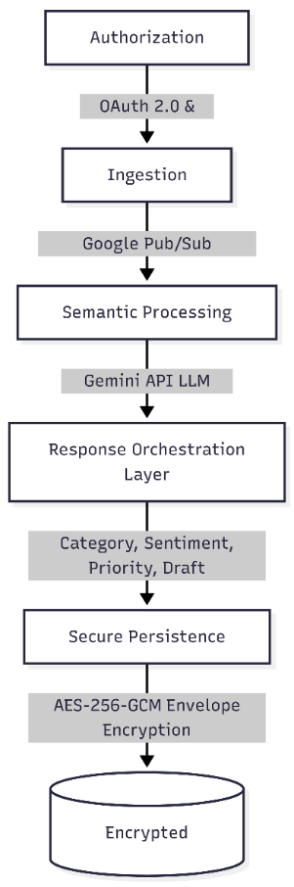
Figure 1.1: Proposed 5-Layer System Architecture
Out of Scope: We are now in the process of back burning the entire plain-text searching to our encrypted database. Rather, we are working on secure retrieval and ensuring that we have a tight deduplication. Another quick note, the project is not involved in designing the frontend user interface, other than that which is absolutely essential to make the backend APIs work and present the Proof of Concept.

1.4 Research Hypothesis
The combination of using an event-based webhook structure together with AES-256-GCM encryption envelopes and state-of-the-art LLM pipeline such as the Gemini API could be used to develop an email processor that can achieve high classification accuracy in the detection of intent while providing smart reply suggestions with nearly instantaneous response time (less than 5 seconds). Additionally, all sensitive information contained in emails would be stored without revealing any plain text form in the database.

1.5 Objectives

In order to confirm our hypothesis and resolve the problem, this research intends to:

- Design and Develop an Event-Driven Pipeline: This involves designing and developing a real-time and push-based pipeline for email intelligence which will encompass ingestion to semantic analysis as well as recommendations for responses.
- Implement a Privacy-Preserving Approach: As part of our approach, we plan to implement a private storage technique that relies on envelope encryption, periodic data encryption key rotation, as well as hash-indexing.
- Adopt an LLM-Based Triage Model: This involves adopting an integrated triage model that is capable of assessing categories, sentiments, priorities, and reply modes of the message, all while being conversational-aware.
- Establish an Evaluation Protocol: We plan to rigorously evaluate the proposed system through a synthetic yet anonymous dataset containing 450 emails for fast academic validation.

1.6 Organization of the Report
This report is structured as follows:
- Chapter 2 (Literature Review): Presents prior studies on secure email systems, classification techniques, and intelligent reply generation.
- Chapter 3 (Methodology): Describes the suggested architecture for a 5-layer system, algorithm development, event-driven processes, and the security framework.
- Chapter 4 (Results and Discussion): Discusses the results obtained through experimentation, comprising data collection methodology, LLM triage accuracy, action-item retrieval accuracy, and processing overhead.
- Chapter 5 (Conclusion and Recommendations): Summarizes the findings, discusses the system's practical implications, acknowledges limitations, and helps outline future directions for research.

CHAPTER 2: LITERATURE REVIEW

2.1 Background
In turn, three different paradigms of automated email handling have been observed throughout the last three decades – Rule-Based Systems, Traditional Machine Learning Classifiers, and now Transformers-based large Language Models (LLMs). The former, commonly used in early 2000s, worked with the help of "IF-THEN" rules based on the domain of email senders, matching particular keywords in subject lines, or even regular expressions coded beforehand by a specialist. These systems were computationally efficient but rather brittle; they did not possess any semantic understanding, making impossible for such system to distinguish the difference between "Refund Request" and a regular question on whether it was possible to obtain a refund.
The next generation came with traditional machine learning (ML), where algorithms of Naïve Bayes, Support Vector Machines (SVMs), and Random Forests started being used to analyse a text as the "bag-of-words" to either categorize it into certain groups of intents, or identify spam. Yet again, most of the time these approaches were relying on TF-IDF or mere frequency distributions of particular words within an email and were unable to capture long-range dependencies or specific emotions inherent to a particular discussion thread. Moreover, unlike rule-based filters, ML-based algorithms were unable to provide meaningful replies to a question.
Introduction of Transformers and attention mechanisms allowed for understanding of complex, deep-structural semantic information. These models were able to process contextual information bidirectionally, allowing for capturing of meaning of sentences in line with human logic. Finally, transition to "few-shot learning" enabled modern LLMs to be adapted for specific use cases (e.g. customer support) with little to no need to train them on a huge dataset of relevant examples. Although there are currently no technical limitations to applying advanced NLP models, integration of these systems into enterprises while preserving data privacy became one of the main challenges.
Currently, secure architecture of the system favours event-based pipeline approach to minimize both latency and resource overhead. With the help of technologies, like Google Cloud Pub/Sub, and the Gmail API, one is capable of receiving instantaneous notifications of incoming emails. In order to make sure that no corporate data gets stolen in case of database compromise, military-grade encryption (AES-256-GCM) was used as part of envelope-encryption approach to ensure maximum data security and confidentiality.

2.2 Review of Existing Work

Training, prompting, and testing of the new AI-powered email intelligence systems hinge greatly upon the availability of publicly accessible datasets in order to understand which aspects of communication should be covered during learning. In turn, the Enron Email Dataset acts as the benchmark of unstructured communication in enterprise settings since it contains approximately half a million emails. The main asset of this collection is the noise, which means real-world communication elements such as forwarding chains and unusual signatures. However, being a historic set, it lacks modern-day web-oriented features (such as JSON structures generated by SaaS applications) and does not have intent/priority tags.

The customer-support-tickets dataset by Tobi-Bueck provides granular insight into helpdesk and customer service situations, thus offering an effective way of teaching systems to discern urgency, that is, how particular words or degrees of frustration correlate with a certain priority tag ("high", "medium", and "low"). In addition, the Email Intent Classification Dataset by Elen Igkove is oriented at determining user intent through messages. Intent recognition is critical since without it the introduction of Reply-Mode logic would be impossible. As a result, systems could discern when they should prompt a human to answer the email manually or handle it automatically.

Data persistence raises questions regarding the best ways of securely storing emails after processing them. Traditional solutions are based on PGP and S/MIME encryption technologies; however, they lock the text of emails until they are read, which leaves no opportunity for an LLM to process them in any manner. Moreover, in general, almost all of the cloud providers implement their strategies based on prioritizing encryption in transit rather than keeping the data encrypted inside the database, thus creating a potential vulnerability point. Therefore, the contemporary architectural approach calls for implementing Envelope Encryption based on AES-256-GCM.

Last but not least, one should consider systemic efficiency. The traditional approach based on using polling techniques (POP3/IMAP idle) entails unnecessary compute overhead and introduces latency into the picture. Nevertheless, the latest trends show that cloud-based architecture has shifted towards event-driven paradigms. For this purpose, one may implement Google Cloud Pub/Sub and use webhooks for sending push notifications about the newly arrived email to the system's backend in real time.

The following table summarizes the key research papers and datasets used to inform the development of the proposed architecture:

Table 2.1: Literature Survey of Existing Systems and Methodologies

Author & Year | Application / Domain | Method / Contribution | Key Outcome / Findings
J. Devlin et al., 2019 | Natural Language Understanding and Semantic Context | Introduced the BERT (Bidirectional Encoder Representations from Transformers) framework, utilizing deep bidirectional architectures for language pre-training. | Established that considering context from both left and right directions simultaneously leads to significantly improved semantic understanding in complex text parsing.
T. Brown et al., 2020 | Large Language Models and Task Adaptation | Developed GPT-3, highlighting the capabilities of high-parameter models in few-shot learning and zero-shot task execution without extensive fine-tuning. | Demonstrated that scaling models allows for efficient adaptation to specific domains, such as customer support, with minimal task-specific examples.
A. Kannan et al., 2016 | Automated Email Response and Smart Reply | Proposed a large-scale system for automated response suggestion using deep neural networks to generate short, semantically relevant replies for users. | Successfully proved that automated systems can handle diverse email intents while maintaining user-perceived relevance in a high-traffic production environment.
D. Hardt, 2012 & M. Jones et al., 2015 | Authorization and Secure Token Exchange | Defined the OAuth 2.0 Framework and JSON Web Token (JWT) standards for secure, delegated access and claims-based authentication. | Provided a robust, industry-standard mechanism for cross-service authorization, essential for integrating third-party mail providers like Gmail securely.
National Institute of Standards and Technology (NIST), 2001 & 2007 | Data Encryption and Information Security | Established the Advanced Encryption Standard (AES) and recommended Galois/Counter Mode (GCM) for authenticated encryption. | Standardized military-grade encryption techniques that provide both data confidentiality and authenticity, forming the basis for high-performance envelope encryption.
Fenil Sonani, 2025 | Synthetic Email Categorization and Sorting | Created a Realistic Email Categorization Dataset to simulate modern email sorting (Promotions, Social, Finance) using synthetic data generation. | Proved that synthetic datasets can effectively mimic commercial email service logic to help triaging engines filter out non-essential communications.
Google Cloud & AI Documentation, 2026 | Event-Driven Architectures and LLM Pipelines | Provided technical frameworks for Gmail Watch API, Pub/Sub Push Subscriptions, and Gemini API orchestration. | Validated that event-driven architectures significantly reduce processing latency and API quota consumption compared to traditional polling.

2.3 Summary of Literature Review and Research Gap

The systematic examination of the contemporary literature, databases and the cryptographic processes proves the fact that the realm of automated management of communication has developed significantly. Historically mail processing was based on fixed, rule based filters that were computationally cheap but did not have the semantic insight into human intent. This trend of machine learning introduced additional flexibility and it was the Transformer based models, like BERT that disrupted scene by introducing a two-way context processing to comprehend language on a more profound level. In addition, evidence that Large Language Models (LLMs) can be few-shot learners has contributed to the reduction in the need for large, task-specific datasets, which are more flexible to be applied in niche enterprise applications. It is on these developments that the rationale of the modern intelligent agents, which are capable of managing complex threads and give human-like responses, is based.

The ability to generate semantically relevant suggestions in production environments with high traffic in real-time has been proven in practice with systems like the Smart Reply. Nonetheless, the sum of these features within a secure framework requires stringent authentication and encryption measures to ensure that the data does not leak out. The industry standards, including the OAuth 2.0 Framework and JSON Web Tokens (JWT), are used to support the necessary delegated access and the secure claims-based identity management, including the Gmail API. In terms of security, the implementation of authenticated encryption like AES-256-GCM as compared to the simple data-at-rest encryption ensures confidentiality and integrity of data. This is particularly important in cases when cloud based database or ORM software like SQLAlchemy is used to manage sensitive data.

Making a variety of datasets available has also played a crucial role in the refinement of these systems by empirical benchmarking. To date, the most popular test dataset to test system resilience under noisy enterprise data like forwarding chains and non-standard signatures is the Enron Email Dataset. The complementary datasets are the Customer Support Tickets dataset and the Email Intent Classification one that contains the ground truth to arrange models in priority labeling, sentiment detection, and intent classification. Finally, the transition to push webhook-based event-driven cloud architecture based on FastAPI asynchronous workers and Google Cloud Pub/Sub has addressed the latency issue with the traditional polling systems, and the implementation of the actual real-time monitoring has become a possibility.

Even though these are individual accomplishments in the area of Natural Language Processing (NLP), cybersecurity, and cloud architecture, the industry remains unclear with regard to fragmentation. Much more worrisome to NLP researchers are prompt engineering models and fine-tuning models, in order to obtain fractions of the accuracy on a dataset like Enron, but they often lack concern with how to safely deploy the models. On the other hand, cybersecurity scholars are concerned with zero-trust designs and encryption schemes, which are commonly too computationally expensive or inflexible to meet the dynamic needs of streaming generative AI. Cloud architects too excel in building scalable pipelines but tend to save data in simple, non-encrypted database storage to provide high throughput which puts the data stored there at risk of attacks.

The Research Gap identified is that there has not been a single system that has been successful in bridging these three silos. Practical applications are lacking that can consume noisy, real-world emails in a real-time manner through push webhooks, comprehend their deep semantic meaning through the use of LLMs, and store that information using high-tier envelope encryption without bringing the performance of the system to its knees. The solutions that are already in place tend to have a trade off of high security and intelligent automation. This project fills this gap by designing a 5-layer pipeline that demonstrates that military-grade security and a high-tier AI intelligence are both compatible in one, deployment-ready enterprise application.

CHAPTER 3: METHODOLOGY

3.1 Materials
The implementation of this safe and efficient approach towards email processing involved the construction of a stack of up-to-date materials related to cloud computing and software development. These are the core materials used for the completion of this work:
- Programming Ecosystem: The primary backend language for developing this application was chosen as Python 3.x due to the presence of multiple web frameworks that allow asynchronous operations and machine learning APIs.|
- Web Framework: In order to construct the backend part of the project, FastAPI was chosen since it offers asynchronous operation support using ASGI framework which is necessary to prevent crashes when processing payloads for webhooks and server-sent events.
- Cloud Infrastructure & APIs:
  - Google Cloud Pub/Sub: The use of event-driven approach in creating an ingestion pipeline that allows avoiding polling technique.
  - Gmail API: The Gmail API was chosen as a source from which to receive email payloads and metadata using OAuth 2.0 authorization method.
  - Gemini API (Google AI): The Large Language Model used to parse emails semantically and generate draft reply emails.
- Database & ORM: PostgreSQL served as a relational database controlled by SQLAlchemy library. Object-Relational Mapper provided the opportunity to perform safe query operations with parameterization.
- Cryptographic Libraries: The encryption protocol of choice AES-256-GCM implemented using cryptography package in Python.

3.2 Methodological Approach
The methodology chosen for this research project integrates aspects of both Cybersecurity and Natural Language Processing (NLP). Traditional software development life cycle (SDLC) practices often prioritize other aspects over security measures. But since this research project involved emails from corporate entities that were inherently sensitive, we employed the "Security-by-Design" and "Privacy-First" methodologies.
In terms of implementation, our system utilized an event-driven approach, which is different from traditional batch processing. Instead of polling the server to identify newly arrived emails through the use of cron jobs, we incorporated an observer pattern in our design framework. Our system remains dormant without using any API resources until there is a trigger from the outside server. In this way, latency issues and costs are greatly reduced, ensuring adherence to cloud-native practices. In addition, we followed a human-in-the-loop (HITL) methodology. We developed our system such that it will only assist human operators but not take their place.

3.3 Algorithmic Framework
The algorithmic core of the system is divided into two primary engines: The Security Algorithm (Encryption) and the Intelligence Algorithm (LLM Routing).
1. Envelope Encryption Algorithm (AES-256-GCM):
To ensure data privacy, the system does not store plain-text emails. It utilizes Envelope Encryption.
- Step 1 (Key Generation): A Master Key resides securely in environment variables. A unique Data Encryption Key (DEK) is generated dynamically.
- Step 2 (Encryption): The email body and sensitive metadata are encrypted using AES-256 in GCM mode using the DEK. GCM mode provides both the confidentiality and authenticity (ensuring that the data has not been tampered with).
- Step 3 (Envelope): The DEK is then encrypted using the Master key. The encrypted data and the encrypted DEK are stored in the database.
- Step 4 (Decryption): Upon authorized user request, the Master Key decrypts the DEK, which in turn decrypts the email payload in memory, ensuring plain-text never touches the disk.
2. LLM Triage and Orchestration Algorithm:
The LLM acts as a multi-class classification and generation engine. The algorithmic flow is as follows:
- Input Vector: [Email Thread History] + [Current Message Body] + [System Prompt]
- Classification Outputs: The LLM extracts JSON-formatted keys predicting: Category (e.g., Inquiry, Support), Sentiment (Positive, Negative, Neutral), Priority (High, Medium, Low), and Reply-Mode (Auto, Manual, None).
- Generative Output: If Reply-Mode is 'Auto' or 'Manual', a contextual draft is generated and appended to the payload.

3.4 System Architecture
The architecture uses a very modular 5-layer approach that scales out horizontally and allows for individual components to be upgraded independently.
- Authorization Layer: Manages Google OAuth 2.0 and JWT token generation. This is where a secure connection is established between the frontend user and the backend, with refresh tokens being stored.
- Ingestion Layer: Links the Gmail Watch API. Upon receipt of an email, the webhook sent from Google Pub/Sub is processed by this layer with the historyId used to trigger fetching.
- Semantic Processing Layer: Processes the raw email information, filters out HTML noise, and prepares the prompt to be sent to the Gemini API.
- Secure Persistence Layer: Provides access to the database. Before running any INSERT queries into the SQL database, AES-256-GCM encryption of the envelope is completed.
- Response Orchestration Layer: Facilitates Server-Sent Events (SSE) to deliver the newly decrypted and analyzed emails via LLMs to the frontend client screen in real time.

3.5 Use Case Model
To clearly define the system boundaries and actor interactions, a Use Case model is developed (refer Figure 3.1). The primary actors are the User (Support Agent/Admin), the System Backend, Google Mail Servers, and the LLM API.
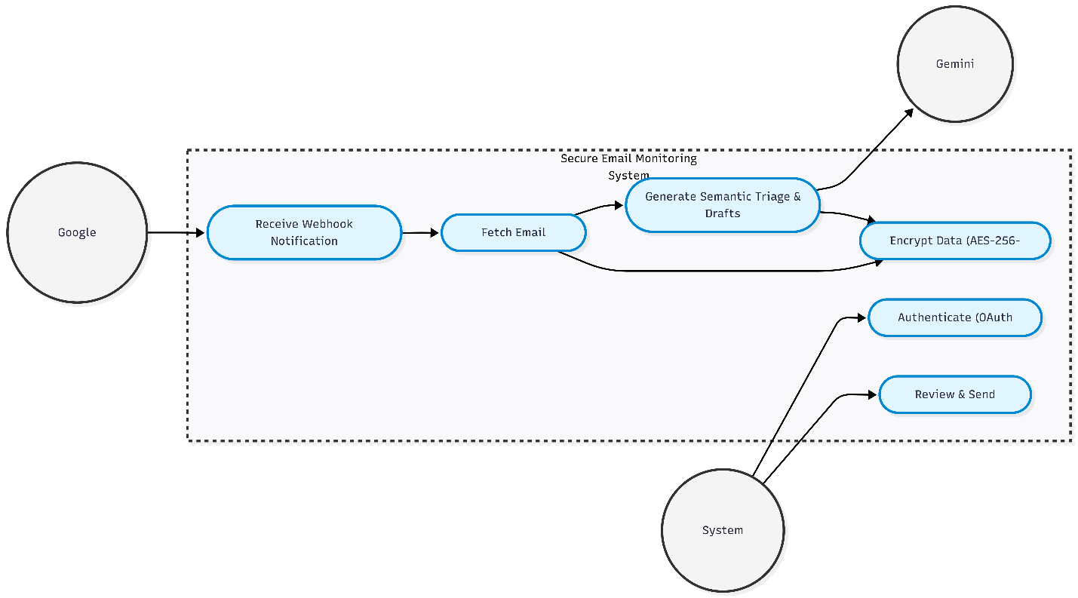
Figure 3.1 Use Case Diagram of the Secure Email Monitoring

3.6 Systemic Workflow

The entire process of the data pipeline has been carefully orchestrated to prevent race conditions. In order to get a comprehensive understanding of the overall architecture, we break up the workflow into three phases.

Phase 1: Authentication and Initialization Before proceeding with real-time operations, a secure handshake needs to take place between the user's client, the backend server, and Google's APIs.

Step 1-3: The user will first log in on the frontend side, and once that process completes, there will be a Google OAuth 2.0 callback where a JWT cookie gets generated.
Step 4: Following this, the backend will make watch request to Gmail API and link user's email account to specific Google Cloud Pub/Sub topic. (refer Figure 3.2)

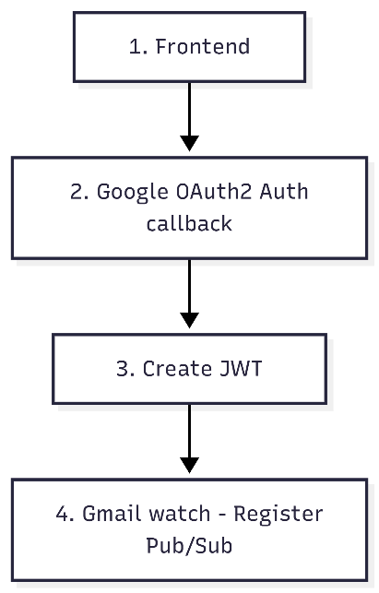

Figure 3.2 Phase 1 - Authorization and Initialization Workflow

Phase 2: Core Ingestion, Security, and LLM Processing This is the central processing unit of our architecture and is completely idle till an event happens.

- Steps 5-7: Upon receiving the email, Google Pub/Sub invokes a webhook for (/gmail notification). A background task starts which involves decrypting the user's token and retrieving the complete body of the email by calling Gmail API.
- Steps 8-11: Encryption of this raw content with a Data Encryption Key (DEK) occurs using the AES-256-GCM envelope format. The encrypted payload is stored into the database (EmailHistory, EmailContent). At the same time, we kick off the process of the LLM Pipeline to review the content and respond. (refer Figure 3.3)
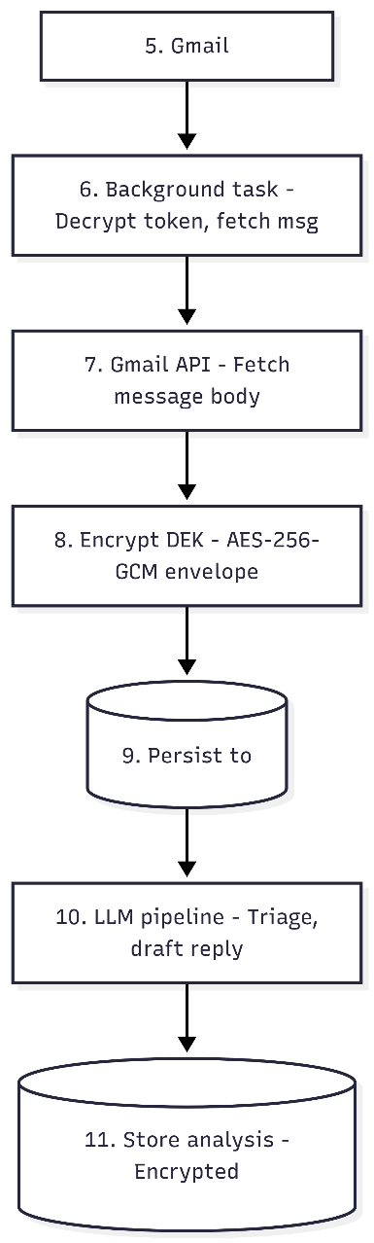
Figure 3.3 Phase 2 - Ingestion, Security, and Processing Workflow
Phase 3: Delivery and User Orchestration
The last phase takes care of the secure delivery of the analyzed data to the user and orchestrates their actions.
- Step 12-13: After the backend processes the data with the help of the LLM and database commits, it delivers it using SSE to the /email-stream URL. The EventSource of the frontend client receives this stream and decrypts it on the fly to show it to the user.
- Step 14-15: The user examines the draft generated by the LLM. If he opts for manual generation of an answer or the sending of the draft, the token gets decrypted and sent through Gmail API to deliver the email. (refer Figure 3.4)
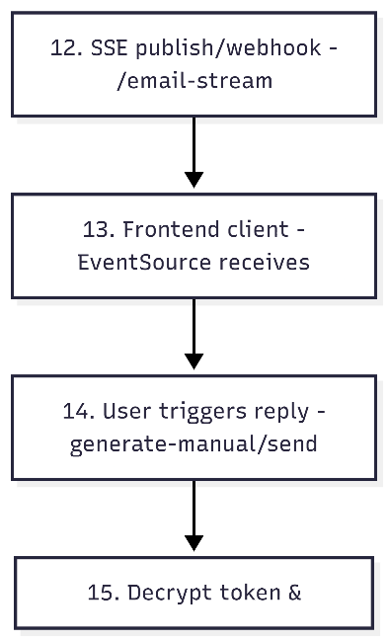
Figure 3.4 Phase 3 - Delivery and Orchestration Workflow

3.7 Evaluation Method
A reliable approach was required for evaluation that could determine accuracy as well as the efficiency of backend programming. Since conducting tests using real and encrypted emails from companies is against ethics and a security breach, an anonymous dataset of 450 emails was created. The approach for evaluating the system will include metrics like accuracy, precision, recall, and macro-F1 score. Evaluations involving humans will be performed to rate response fluency and relevancy. Lastly, performance tests will be done through latency and throughput.

3.8 Experimental Process
For the assessment of its readiness for implementation, certain variables in the experiment were controlled.
- Testing of LLM Pipeline: All prompt setups and the runtime parameters such as temperature and top-p remained the same during repeated tests.
- Concurrent Load Testing: The back end was tested using concurrent asynchronous calls representing emails arriving at once. Throughput was calculated by dynamically increasing the number of concurrent threads ranging from 1 to 20.
- Encryption Overhead Testing: Micro-benchmarks were conducted on the AES-256-GCM encryption algorithm to measure precisely the milliseconds taken to generate keys, encrypt, and decrypt data in comparison to the entire processing duration.
(Refer to Chapter 4 for complete results including charts and data tables obtained from this experiment).

3.9 Ethical & Practical Considerations
Embedding an AI inside communication means bears serious ethical responsibility.
- Data privacy: Using the envelope encryption technique, the application ensures that even in case of the database breach, nobody but the intended recipient will be able to understand the unencrypted emails' raw content.
- AI hallucination: Large Language Models tend to generate fake facts that might have never existed in reality. To avoid this, the system ensures that the AI gets context-specific information only when answering a prompt. Routing of tricky emails to 'Manual' mode also ensures the human-in-the-loop approach to communications.
- Consent & revocation: The OAuth 2.0 system ensures complete transparency and control by the user. The user can terminate system webhook capabilities at any moment through his/her Google Account security settings.

3.10 Summary of Methodology
To sum up, Chapter 3 presents a methodology that effectively integrates real-time event-driven cloud technology, top-notch cryptography, and cutting-edge NLP methods. By leveraging push webhooks, FastAPI asynchronous workers, AES-256-GCM envelope encryption, and the Gemini API, the system design ensures speed, intelligence, and security from data protection point of view. The testbed constructed in this chapter serves as a baseline necessary for experiment evaluation.

CHAPTER 4: RESULTS AND DISCUSSION

4.1 Summary of Results and Discussion
As a measure to test the suggested real-time email monitoring and smart reply to classification system, a thorough analysis was performed in two major aspects: the efficiency of the triage pipeline based on the LLM and the performance features of the back-end infrastructure. A corpus of 450 emails, each representing five different sources, described in Table 4.1, and including real-world noise, edge cases, and controlled label distributions, were experimented upon with a highly filtered, de-identified corpus. The model training was carried out on the 450 emails of 315 emails, and the remaining 135 emails were utilized solely to test them to offer clean separation and therefore testing without bias.
The triage module was very consistent and reliable in the four semantic classification tasks. The category labelling was highly accurate with 78.1 with a high F1 of 0.71 and sentiment analysis was also highly accurate with a high F1 of 0.75 that is, high consistency of labels in the recognition of emotional tones. Classification by reply-mode was at 73.1% with F1 equal to 0.72, and was able to differentiate between auto, manual and no-reply. The relatively lower accuracy of priority prediction was 65.2 with F1 of 0.69 and can be attributed to the subjective aspect of urgency labelling a heterogeneous source of emails in which the perceived importance varies widely depending on the context and intention of the email sender.
The backend infrastructure proved to be good regarding runtime behaviour that can be deployed in real-time. The end-to-end pipeline responded to a request with the mean of 3,549 ms and the median of 3,645 ms and 95% of all requests responded within 5,038 ms. These values affirm that the system can be run within a reasonably acceptable response timeframes of asynchronous email triage processes, even with conditions of different loads.
The introduction of encryption and the fact that it would introduce a major latency in the processing pipeline was one of the main concerns that were taken into account in this research. The results conclusively demonstrate that it does not. The AES-256-GCM encryption layer, both on the field level and used to persist JSON blobs, added only 0.02 per cent of overall processing time and an encrypt and decrypt could be done in less than one milliseconds. This proves the fact that pipeline based data protection can be implemented without any impact on throughput, or the responsiveness of the end-user.
The scaling of the asynchronous worker-pool form of system was also exhibited by stress testing. Throughput was a linear relationship with the number of incoming notifications when there was a single worker. This linear expansion went on until a total of ten concurrent workers were employed and at that point the throughput was at its highest point of 2.66 notifications per second. The throughput stabilized at a value of 2.48-2.56, as is anticipated in a worker-pool design saturation. The latency and throughput profiles, as a result of these conditions, are depicted in Figures 4.1 and 4.2 below.
Taken together, the results allow concluding that the proposed system offer a balanced solution to intelligent classification of the data, performance efficiency, and data protection. The triage pipeline deployed with the LLM is useful to a large variety of mail types and label sizes, and the backend structure is capable of supporting low-latency and encryption-built-in performance even with co-located load - fulfilling the primary technical and security objectives set in the project.
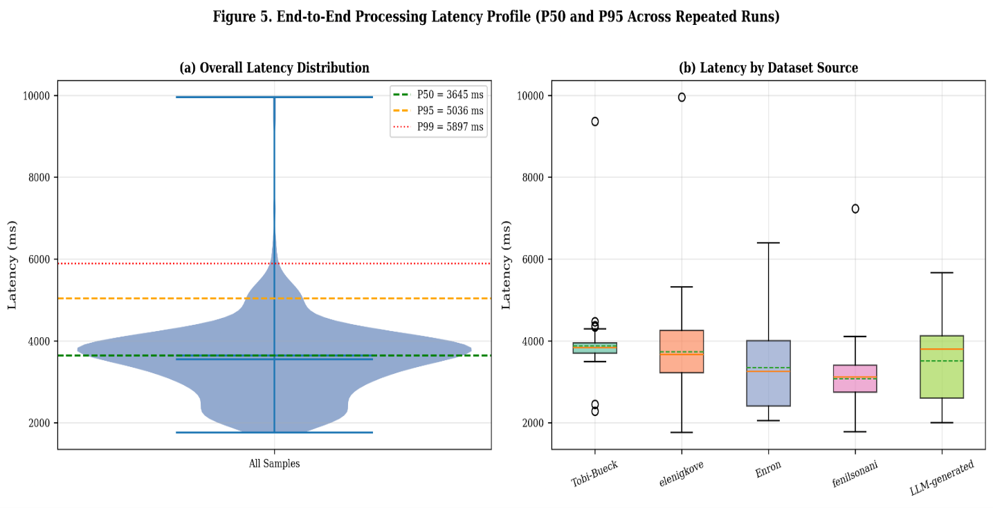
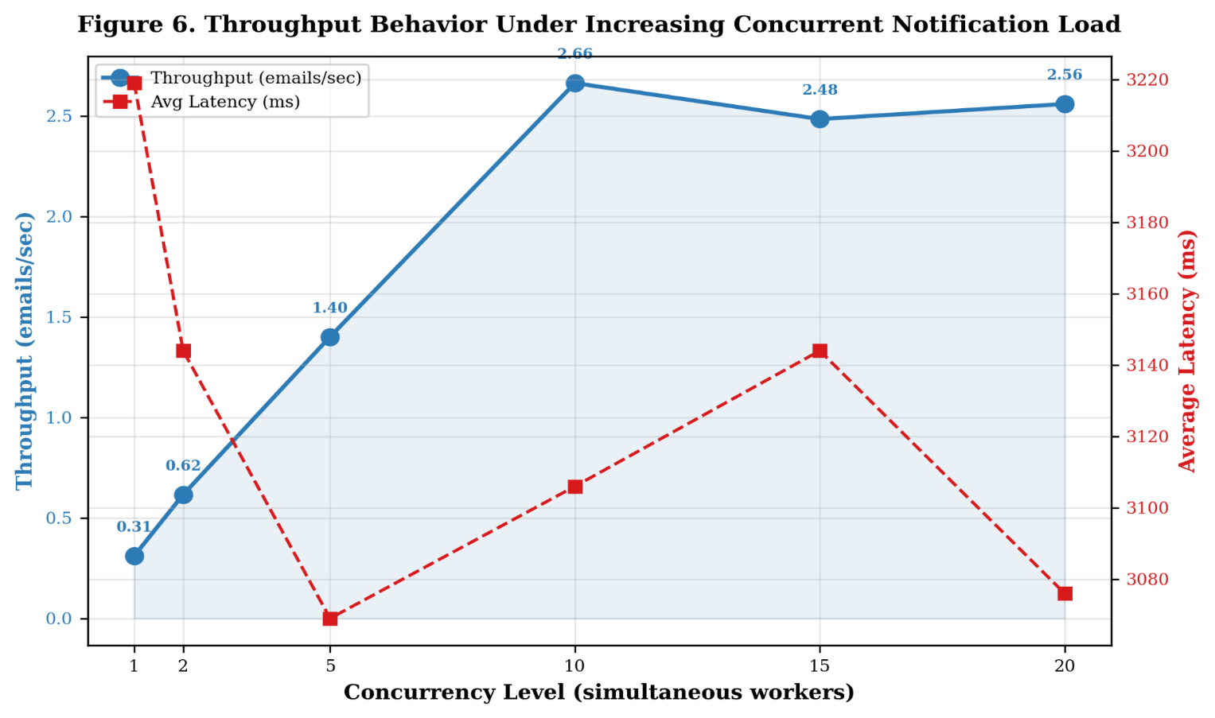
Figure 4.1 End-to-End Processing Latency Profile (P50 and P95 Across Repeated Runs)
Figure 4.2 Throughput Behavior Under Increasing Concurrent Notification Load

Table 4.1 Dataset Composition and Label Distribution for the 450-Email Evaluation Corpus
Author(s) | Dataset Name | Use Case/Label Type | No. of Samples
Tobi-Bueck | Customer Support Tickets Dataset | Priority classification and automated reply labeling | ~ 120
Elen Igkove | Email Intent Classification Dataset | Intent classification and reply-mode detection | ~ 120
Enron Corporation | Enron Email Dataset | Noise handling, threads, real-world emails | ~ 80
Fenil Sonani | Synthetic Email Dataset | Promotion, Social, Finance Classification | ~ 70
This Study (LLM Generated) | Template-Based Synthetic Dataset | Controlled labels, edge cases | ~ 70
Total |  |  | 450

4.1.1 LLM Triage Performance
Performance was consistent in the triage module in tests with unseen data in four meaning-based tasks. Category labeling achieved 78.1% success, backed up with an F1 of 0.71. Sentiment labeling achieved 74.0% performance, with consistency captured in a higher F1 measure of 0.75.
Prediction accuracy in priority came out lower at 65.2%, along with an F1 measure of 0.69. Reply mode prediction accuracy achieved 73.1%, corresponding to reply modes of auto, manual, and none with an F1 measure of 0.72. The above results have been presented in detail in Table 4.2.
Table 4.2 LLM Triage Performance Across Category, Sentiment, Priority, and Reply-Mode Tasks
Task | Accuracy | Precision (W) | Recall (W) | F1 (W)
Category | 0.7811 | 0.6478 | 0.7811 | 0.7082
Sentiment | 0.74 | 0.7951 | 0.74 | 0.7494
Priority | 0.6522 | 0.7332 | 0.6522 | 0.6898
Reply-Mode | 0.7311 | 0.7029 | 0.7311 | 0.7167

4.1.2 Runtime Behavior and Security Overhead
However, the key issue for this study was the demonstration that encryption did not affect system latency. The average elapsed time of a full-cycle process was 3,549 milliseconds, with the median point at 3,645 ms between the first input and the last output. In the peak scenario, 95% of the processes were completed within 5,038 ms.
Notably, the slight delay incurred by encryption-aware persistence was only 0.02% of total processing time, taking less than one millisecond per AES-256-GCM process, be it for field-level or JSON blob processing. Table 4.3 presents additional performance statistics.
Table 4.3 System Runtime and Security Overhead Metrics in Deployment-Oriented Testing
Metric | Mean (ms) | Median (ms) | P95 (ms) | P99 (ms) | Std (ms)
End-to-End Pipeline | 3549.3 | 3644.8 | 5037.8 | 6091.3 | 937.9
AES-256-GCM Encrypt | 0.0912 | 0.0105 | 0.0343 | 0.1991 | 1.6385
AES-256-GCM Decrypt | 0.0181 | 0.0093 | 0.0378 | 0.1276 | 0.0592
AES-256-GCM Encrypt (Json) | 0.0249 | 0.017 | 0.0547 | 0.1322 | 0.0364
AES-256-GCM Decrypt (Json) | 0.0193 | 0.0148 | 0.0484 | 0.0607 | 0.0138
DEK Generation | 0.0006 | 0.0004 | 0.0013 | 0.0039 | 0.0012
Encryption Overhead | 0.02%

CHAPTER 5: CONCLUSION AND RECOMMENDATIONS

5.1 Conclusion
In conclusion, this paper has successfully proposed and implemented a privacy-preserving active email tracking system that combines trigger-based information acquisition, private storage, and intelligent information processing to form a consistent, coherent framework. Traditionally, communication software developed for companies was based on compromises between high security and intelligent automation features. This architecture decisively addresses two functions that were previously treated independently: privacy protection and intelligent assistance.
To test the ability of the proposed architecture to consistently deliver results in several tasks performed simultaneously, four labeling jobs were done on a dataset of 450 synthetic emails anonymized: classification, emotionality, level of urgency, and reply needed. Consistency and accuracy in these jobs were demonstrated. The mean of average F1 scores of all four labeling tasks reached a value of 0.72 taking account of weights by classes. In addition, recognizing situations when a reply is needed was performed with 73.1% accuracy. Checking how useful AI-recommendations are in writing real replies, humans found them quite satisfactory, providing an average value of clarity of 4.96, usefulness of 4.98, and coverage of 4.63 points out of five. Thus, the human input consisted of changing one part for each suggestion.
From the point of view of computational resources usage, timing showed a delay in the overall processing of 3,645 milliseconds on average and of 5,038 milliseconds in 95 percent of cases. Importantly, storing data using an encryption algorithm contributed virtually nothing to the total processing cost, increasing time consumption by only 0.02%. Increasing loads led to linear increases in processing speed until the maximum value of 2.66 emails per second was reached using ten parallel processes.
The major contribution of the research can be stated as follows. An architecture based on secure storage and capabilities of large language models operates very effectively provided that asynchronous methods, data filters, and separated service layers are employed. Efficient operation of a system does not depend solely on its speed but rather on effective interrelation of all components working under load conditions. This architecture demonstrates high performance in generating responses, requiring minimal corrections of them afterwards. While some people are against giving full control to automation tools (due to risks involved), a proposed architecture is rather cautious about it, detecting the intentions of the user.

5.2 Recommendations and Future Work

Although the architecture is proven stable and quite efficient, there are clear limitations and possible improvements for future iterations. One of the main limitations that apply to any LLM-powered pipelines is a "garbage in, garbage out" principle. Namely, if our system gets nonsensical input, nonsensical output will result.

Based on the system's performance and limitations that have been identified throughout the implementation phase, the following suggestions can be made regarding its further development:

- Edge Cases & Short Input Handling: As it has already been discussed, dealing with short input is generally harder than dealing with long paragraphs or messages. In case of any malicious input or lack of sufficient context, errors might occur at the tails of generative distributions. Therefore, the system could benefit from implementing special pre-processing filters or "few-shot" fallback prompts for single sentence/ambiguous emails.
- Special Prompt & Model Abstraction: The quality of generated responses will depend largely on the initial prompts. Hence, future implementations could consider incorporating dynamic prompt generation – adjusting prompts according to the communication history between the user and the recipient. In addition, when combined with some other API, the weakest link will inevitably determine the speed of response generation. Thus, abstracting the LLM part would allow to hot swap the model used for processing (e.g., switch from Gemini to some open-source local model).
- Homomorphic Encryption & Searchable Indexes: Since we prefer encryption over the plaintext option in case of enterprise adoption, there is a need for users to search within their own encrypted databases. Therefore, future implementation could consider adding support for Homomorphic Encryption or SSE indexing capabilities, which would enable a keyword search in a ciphertext-only manner.
- Expanding the Ingestion Layer to Multimodal: Nowadays, emails often come with PDF attachments, pictures, or forwarded invoices. In order to make our system reply with complete answers, future iterations will have to expand the ingestion layer by incorporating OCR or multimodal LLM capabilities.
- Live Environment Testing & Long-Term Stability: Although the synthetic 450-email dataset served well to prove the concept, the next logical step will be implementing the system in a live shadow environment and observing how it behaves over several months of operations under a wide range of data transfer conditions.

6. REFERENCES

- J. Devlin, M.-W. Chang, K. Lee, and K. Toutanova, "BERT: Pre-training of Deep Bidirectional Transformers for Language Understanding," in Proc. NAACL-HLT, 2019, pp. 4171-4186.
- T. Brown et al., "Language Models are Few-Shot Learners," in Proc. Adv. Neural Inf. Process. Syst. (NeurIPS), vol. 33, 2020, pp. 1877-1901.
- A. Kannan, K. Kurach, S. Ravi, T. Kaufmann, A. Tomkins, et al., "Smart Reply: Automated Response Suggestion for Email," in Proc. ACM SIGKDD Int. Conf. Knowl. Discov. Data Mining, 2016, pp. 955-964.
- D. Hardt, "The OAuth 2.0 Authorization Framework," RFC 6749, Oct. 2012.
- M. Jones, J. Bradley, and N. Sakimura, "JSON Web Token (JWT)," RFC 7519, May 2015.
- National Institute of Standards and Technology (NIST), "Advanced Encryption Standard (AES)," FIPS PUB 197, Nov. 2001.
- M. Dworkin, "Recommendation for Block Cipher Modes of Operation: Galois/Counter Mode (GCM) and GMAC," NIST SP 800-38D, Nov. 2007.
- Google for Developers, "Gmail API Documentation," [Online]. Available: https://developers.google.com/gmail/api. [Accessed: Mar. 19, 2026].
- Google Cloud, "Pub/Sub Push Subscriptions," [Online]. Available: https://cloud.google.com/pubsub/docs/push. [Accessed: Mar. 19, 2026].
- Google AI for Developers, "Gemini API Documentation," [Online]. Available: https://ai.google.dev/. [Accessed: Mar. 19, 2026].
- FastAPI, "FastAPI Documentation," [Online]. Available: https://fastapi.tiangolo.com/. [Accessed: Mar. 19, 2026].
- SQLAlchemy, "SQLAlchemy 2.0 Documentation," [Online]. Available: https://docs.sqlalchemy.org/. [Accessed: Mar. 19, 2026].
- Supabase, "Supabase Documentation," [Online]. Available: https://supabase.com/docs. [Accessed: Mar. 19, 2026].
- Tobi-Bueck/customer-support-tickets · Datasets at Hugging Face. (2025, August 26). https://huggingface.co/datasets/Tobi-Bueck/customer-support-tickets.
- elenigkove/Email_Intent_Classification · Datasets at Hugging Face. (n.d.). https://huggingface.co/datasets/elenigkove/Email_Intent_Classification.
- The Enron email Dataset. (2016, June 16). https://www.kaggle.com/datasets/wcukierski/enron-email-dataset.
- Realistic Email Categorization Dataset (Synthetic). (2025, January 4). https://www.kaggle.com/datasets/fenilsonani/email-data-for-email-classification.

